

*Presented to*

Ian Bowles

Reg Number: 76031

**Dermal Filler Level 2 - Part 2 (Hands-on training)**

Areas covered: Nose (non-surgical rhinoplasty, dorsal hump reduction, nasal tip lifting), chin and jawline,

using a range of Hyaluronic Acid products.

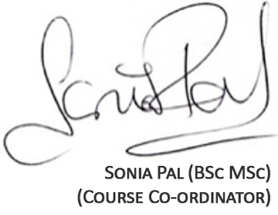

19th January 2023

7 hours CPD

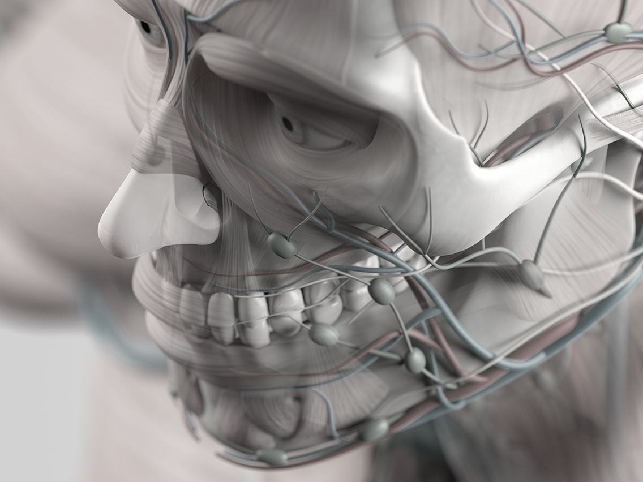

**Dermal Filler Level 3 – Part 2** (Nose, chin & jawline augmentation)

This document is to certify that the recipient has attended the Dermal Filler Level 3 (Part 2) course and is accredited with 7 hours CPD.

**Aims and objectives of this course:**

* A brief recap of Dermal Filler and its common uses in medicine
* Pharmacology and toxicology
* Anatomy and physiology: Mid-face considerations
* The consultation: From assessment to post-operative advice and treatment indications
* Patient management: Expectations and contra indications
* Obtaining valid consent
* VAT implications for cosmetic procedures
* How to achieve safe and predictable outcomes
* Complication management and indemnity information
* Recap – Hyaluronidase: Why it is important and how to use it in an emergency
* Patient preparation & product information
* Hands on practical session: Dermal Filler treatment for nose reshaping, chin augmentation and jawline definition
* Marketing: How to market natural aesthetics
* How to maintain a successful career in the world of Facial Aesthetics

**Learning outcomes:**

* Delegates have the confidence to assess and consult their patients efficaciously
* Delegates have gained knowledge of the protocols & procedures surrounding dermal fillers
* Delegates have an understanding of how to adequately treat patients safely and effectively

**Development Outcomes for GDC Registrants:**

This CPD course meets the criteria for categories A, B, C & D of the GDC's development outcomes.